**ASSIGNMENT 2**

|  |  |  |  |
| --- | --- | --- | --- |
| **Qualification** | **BTEC Level 5 HND Diploma in Computing** | | |
| **Unit number and title** | 10: Website Design & Development | | |
| **Submission date** |  | **Date Received 1st submission** |  |
| **Re-submission Date** |  | **Date Received 2nd submission** |  |
| **Student Name** | Nguyen hoang tuan vu | **Student ID** | Bsa180017 |
| **Class** | Bsa-2001-1 | **Assessor name** | Thai Thi Thanh Thao |
| **Student declaration**  I certify that the assignment submission is entirely my own work and I fully understand the consequences of plagiarism. I understand that making a false declaration is a form of malpractice. | | | |
|  |  | **Student’s signature** | Nguyễn hoàng tuấn vũ |

**Grading grid**

|  |  |  |  |  |  |  |
| --- | --- | --- | --- | --- | --- | --- |
| P5 | P6 | P7 | M4 | M5 | D2 | D3 |
|  |  |  |  |  |  |  |

|  |
| --- |
| **Submission Format:** |
| *Format:*   1. A report document including some sections    * Section 1: A review of appreciate web design principles, standards and guidelines.    * Section 2: Design document for online shopping website.    * Section 3: Implementation of website design. - Section 4: Test plan and test evaluation. 2. A compressed file that encapsulates all source code and particular necessary resources including files of images, style sheets, java script and other files to support to install multipage website such as sql script and installation guide.   *Submission* Students are compulsory to submit the assignment in due date and in a way requested by the Tutors. The form of submission will be a soft copy posted on <http://cms.greenwich.edu.vn/>  *Note:* The Assignment *must* be your own work, and not copied by or from another student or from books etc. If you use ideas, quotes or data (such as diagrams) from books, journals or other sources, you must reference your sources, using the Harvard style. Make sure that you know how to reference properly, and that understand the guidelines on plagiarism. *If you do not, you definitely get failed* |
| **Unit Learning Outcomes:** |
| **LO3** Utilise website technologies, tools and techniques with good design principles to create a multipage website.  **LO4** Create and use a Test Plan to review the performance and design of a multipage website. |
| **Assignment Brief and Guidance:** |
| You work as a full-stack web team leader for a leading creative web solutions and marketing company. Your team is about to have a big contract to develop an online shopping mall.  In order to finish your work effectively you need to review all appropriate principles, standards and guidelines for website designing and development, evaluate all technical challenges to produce a good design document for the online shopping website with wireframes, functional illustrations and a full set of client and user requirements. Then, you lead your team to utilize web design and development technologies, tools and techniques to implement your web design to develop the online shopping website. To get good result, you always ask your team for following your design document by comparison between created multipage website with your design document and evaluation.  As your role, to ensure that the multipage website for online shopping developed by your team is a high quality product, you also need to ask your team members to follow quality assurance process and implement it during your design and development stages by creating a suitable test plan. The test phase should be seriously implemented by reviewing and analysing all test results to evaluate applied quality assurance process and point out suggestions of improvements for online shopping website |

|  |  |  |
| --- | --- | --- |
| Learning Outcomes and Assessment Criteria | | |
| Pass | Merit | Distinction |
| LO3 Utilise website technologies, tools and techniques with good design principles to create a multipage website | | D2 Critically evaluate the design and development process against your design document and analyse any technical challenges. |
| P5 Create a design document for a branded, multipage website supported with medium fidelity wireframes and a full set of client and user requirements.    P6 Use your design document with appropriate principles, standards and guidelines to produce a branded, multipage website supported with realistic content. | M4 Compare and contrast the multipage website created to the design document. |
| LO4 Create and use a Test Plan to review the performance and design of a multipage website | | D3 Critically evaluate the results of your Test Plan and include a review of the overall success of your multipage website; use this evaluation to explain any areas of success and provide justified recommendations for areas that require improvement. |
| P7 Create a suitable Test Plan identifying key performance areas and use it to review the functionality and performance of your website. User Experience (UX) and User Interface (UI). | M5 Evaluate the Quality Assurance (QA) process and review how it was implemented during your design and development stages. |

|  |  |  |
| --- | --- | --- |
| **❒ Summative Feedback: ❒ Resubmission Feedback:** | | |
| **Grade:** | **Assessor Signature:** | **Date:** |
| **IV Signature:** | | |

CONTENT

I. Introduction 9

1.Hardware requirement for client: 9

2.For Developer: 9

2.1 Hardware requirement: 9

2.2 Install Webserver: xampp 10

2.3 Test Webserver: 11

II.Analysis and Design 16

1.Website functions 16

1.1 User (Customer): 16

1.2 Admin: 16

2.Analysis 16

2.1 Use-case: 16

2.2 Wireframes for user home page 19

2.3 Wireframes for product 20

2.4 Database 21

III. Website 23

IV.Coding 26

V.Testing plan 28

1.Testing plan for user 28

2.Testing plan for admin 29

VI.Conclusion 29

*References* 30

# I. Introduction

Online business has never been as vibrant and powerful as it is today. Today, millions of people around the world use the Internet and consider it the ideal place to find information, buy goods and entertainment. the website is a software application that allows online businesses to manage the website, their marketing, sales and operations. It can operate almost 24/7 and significantly reduces the cost of administration and marketing for the business. This has led to a series of e-commerce websites launched to serve the shopping needs of numerous users.

This website's name is ATN technology shop. The website is designed to sell technology products.

## 1.Hardware requirement for client:

|  |  |
| --- | --- |
| Operating system | Windows, Linux, macOS, etc |
| Ram | 2GB recommended 512 MB of free RAM is recommended during the work process |
| CPU | Pentium 4, Athlon 64 or higher with SSE2 support. |
| HDD | 500 MB free space is recommended |
| Browser | Chrome, opera, firefox,etc |

## 2.For Developer:

### 2.1 Hardware requirement:

|  |  |
| --- | --- |
| operating system | Windows, linux, MacOS |
| Ram | Recommended: 8gb  Minimum: 4gb |
| HDD | 5 GB free space is recommended |
| Browser | Chrome, opera, firefox,etc |

### 2.2 Install Webserver: xampp

* Download: <https://www.apachefriends.org/download.html>
* Double-click the downloaded file to launch the installer
* Follow the installation instructions, after the installation is completed, a window similar to the picture will appear below

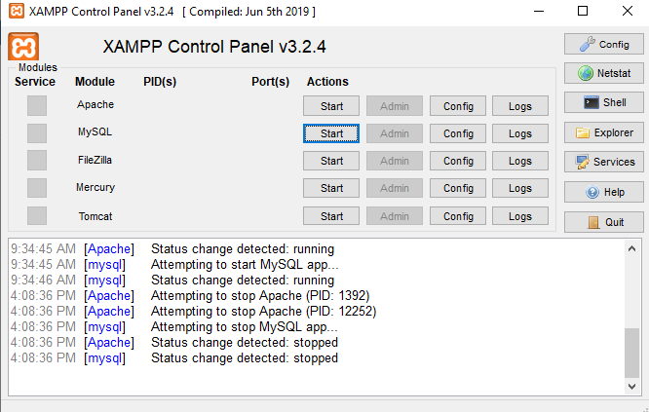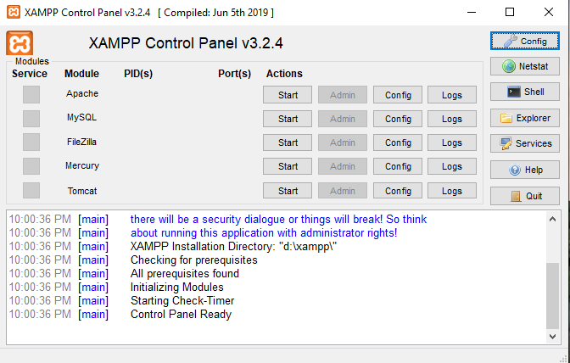

### 2.3 Test Webserver:

- After installing xampp server, we can run the test localhost by running the server

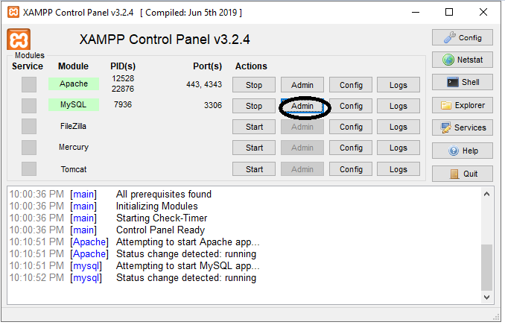

* open your browser and enter the link "localhost" to check if the server is working.

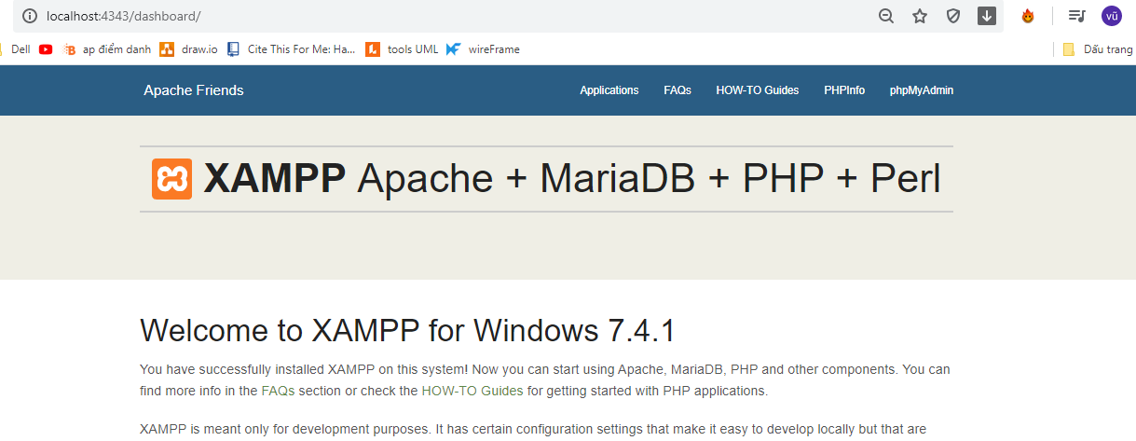

- After the server runs we copy our web directory to the htdocs folder in the apache server installation directory

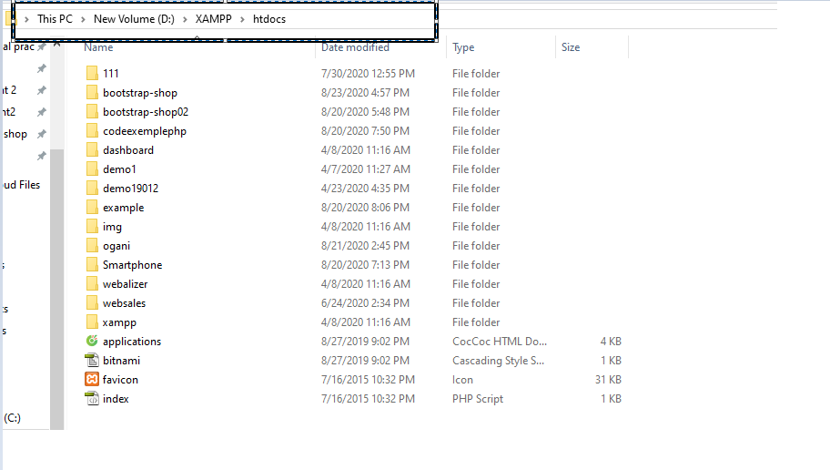

-Attach database : (In the websales file there is a database.sql file ) To import the database yoenter the phpmyadmin page.

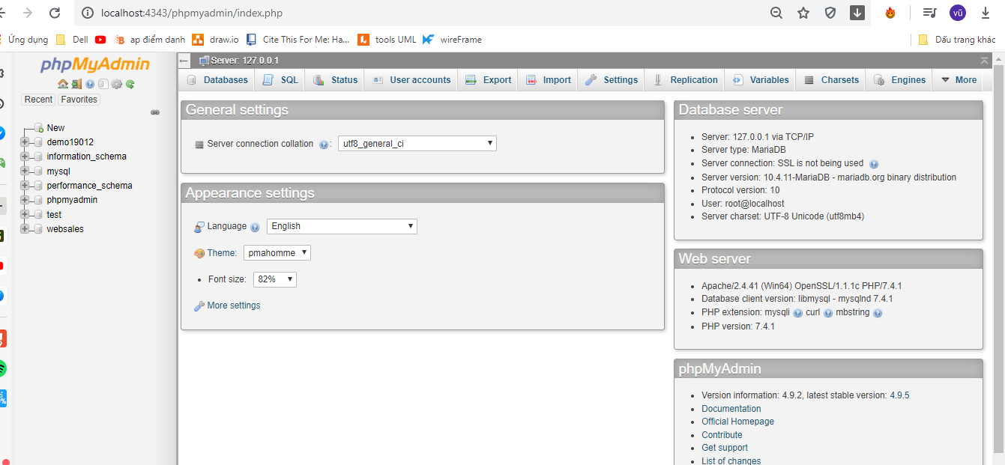

* Click “new” to create new database, input database’s name, and click create.

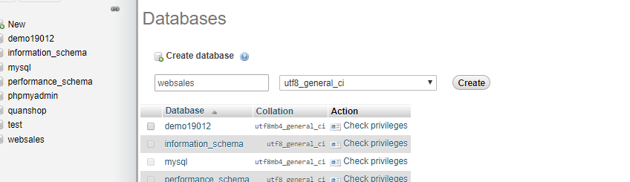

* Click import.

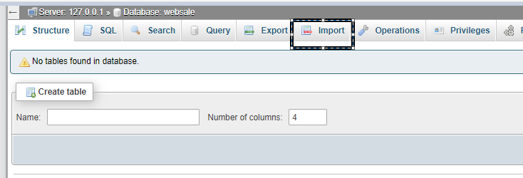

* Click on that icon and select the sql file.

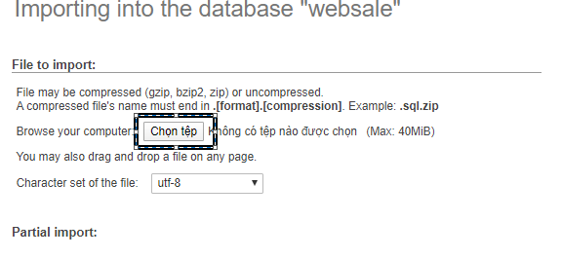

* Select database file and click “go”.

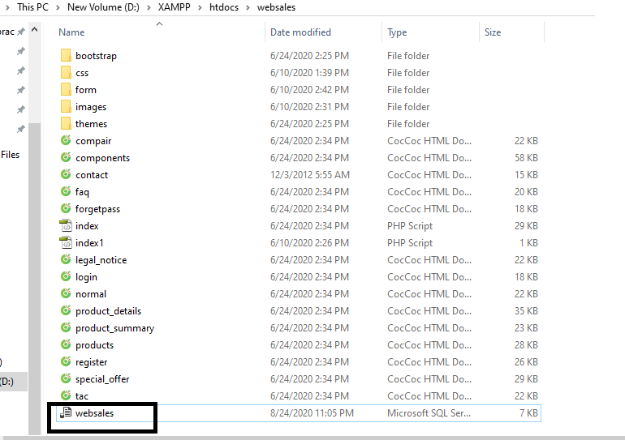

* Database display

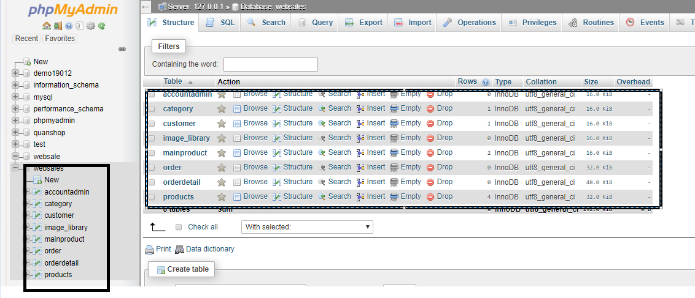

# II.Analysis and Design

# 1.Website functions

### 1.1 User (Customer):

* View list of product
* View list of categories
* View product detail
* Add product to cart
* Remove product from cart
* Order
* Login
* Logout
* Register account

1.2 Admin:

* ✓Products management
* ✓Add new product
* ✓Edit product
* ✓Delete product
* ✓Orders management

**2.Analysis**

### 2.1 Use-case:

- Usecase user:

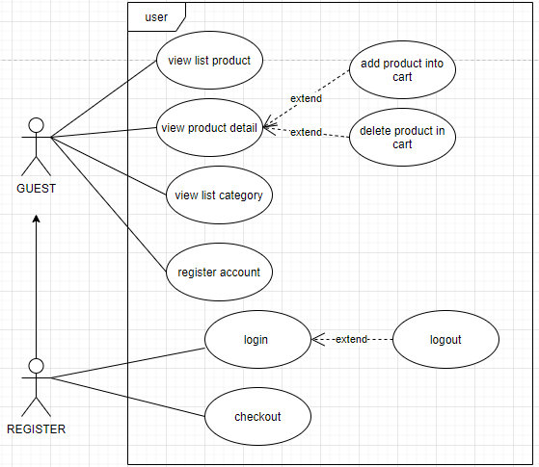

- Usecase admin:

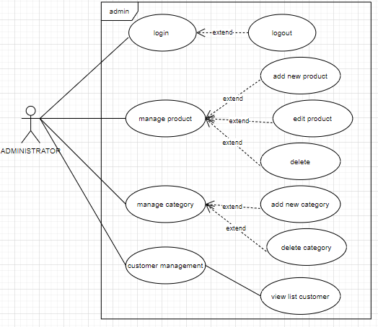

### 2.2 Wireframes for user home page

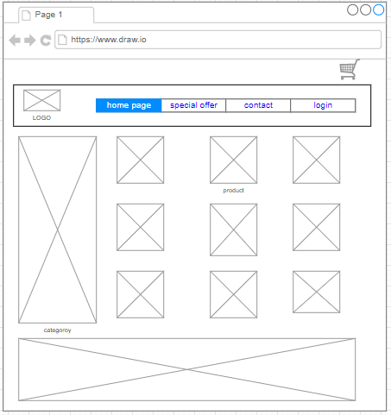

### 2.3 Wireframes for product

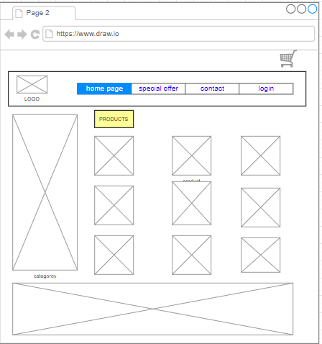

### 2.4 Database

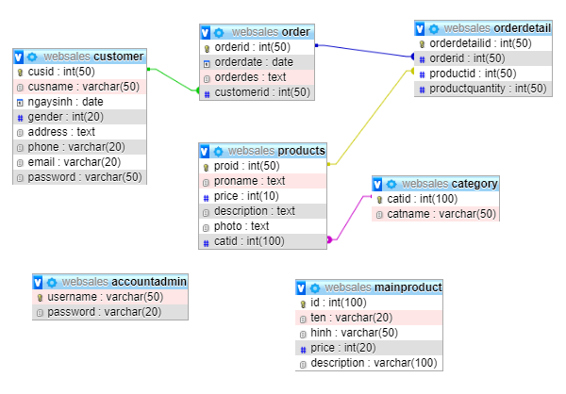

There are 7 tables:

-Customer table

|  |  |  |
| --- | --- | --- |
| **Field** | **Type** | **Constraint** |
| cusid | Int(50) | Primary key |
| cusname | Varchar(50) |  |
| ngaysinh | date |  |
| gender | Int(20) |  |
| adress | text |  |
| phone | Varchar(20) |  |
| email | Varchar(20) | unique |
| password | Varchar(50) |  |

-Product table

|  |  |  |
| --- | --- | --- |
| **Field** | **Type** | **Constraint** |
| proid | Int auto increment | Primary key |
| proname | text | unique |
| price | Int(10) |  |
| description | text |  |
| photo | text |  |
| catid | Int auto increment | Foreign key (category) |

-Orders table

|  |  |  |
| --- | --- | --- |
| **Field** | **Type** | **Constraint** |
| orderid | Int auto increment | Primary key |
| orderdate | date |  |
| orderdes | text |  |
| customerid | Int auto increment | Foreign key (Customer) |

-Orderdetail table

|  |  |  |
| --- | --- | --- |
| **Field** | **Type** | **Constraint** |
| orderdetailid | Int auto increment | Primary key |
| orderid | Int auto increment | Foreign key (order) |
| productid | Int auto increment | Foreign key (product) |
| productquantity | Int(50) |  |

-category table

|  |  |  |
| --- | --- | --- |
| **Field** | **Type** | **Constraint** |
| catid | Int auto increment | Primary key |
| catname | Varchar(50) |  |

-mainproduct table

|  |  |  |
| --- | --- | --- |
| **Field** | **Type** | **Constraint** |
| id | Int auto increment | Primary key |
| ten | Varchar(20) |  |
| hinh | Varchar(50) |  |
| price | Int(20) |  |
| description | Varchar(100) |  |

-account table

|  |  |  |
| --- | --- | --- |
| **Field** | **Type** | **Constraint** |
| Username | Varchar(50) | Primary key |
| password | Varchar(20) |  |

# III. Website

1.Home Page

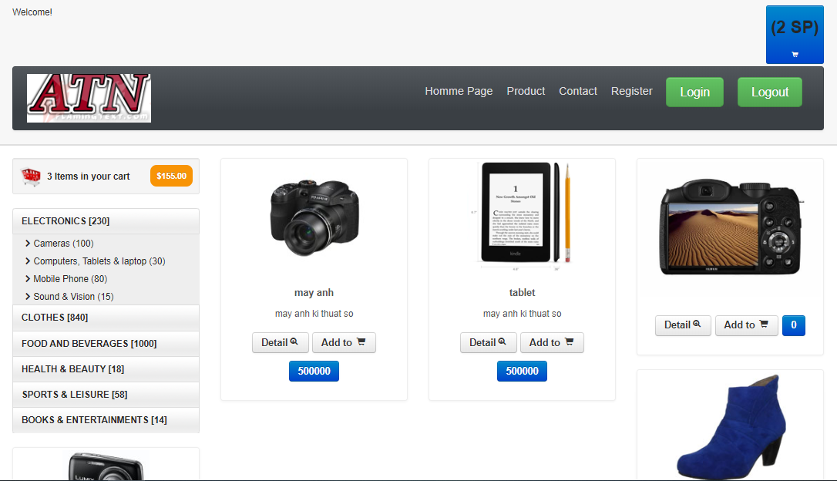

2.Products Information

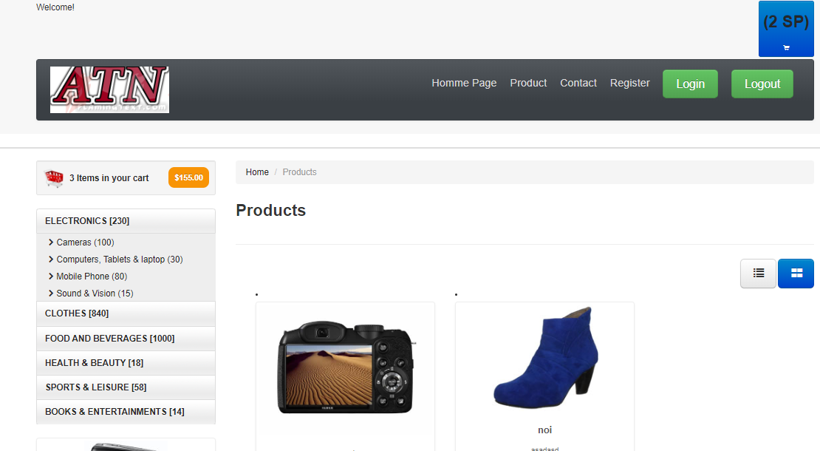

1. Shopping Cart

4.Login

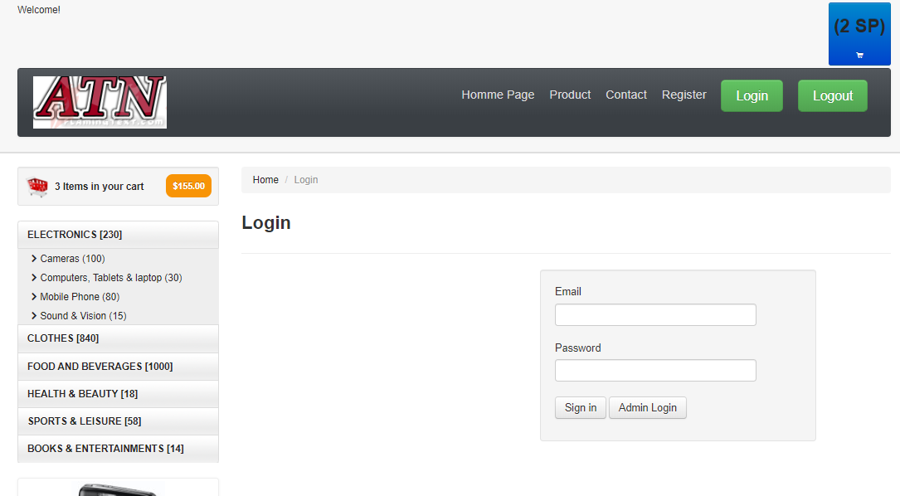

5.Sign Up

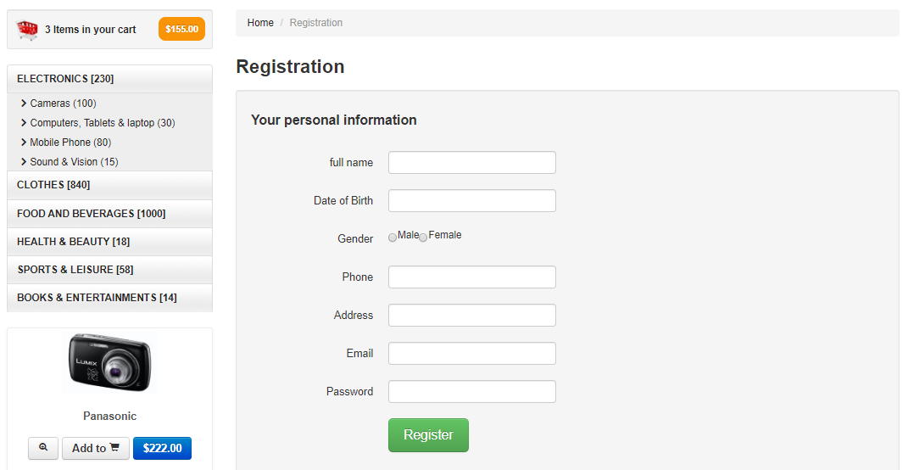

6.Admin page

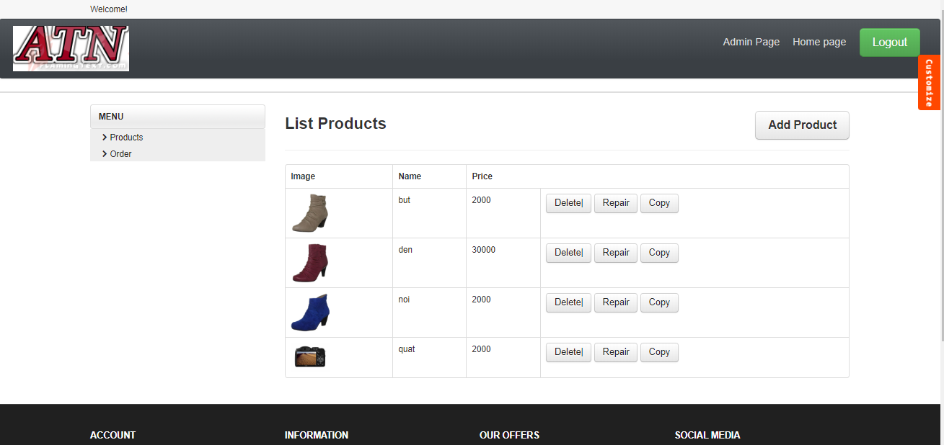

# IV.Coding

1.Connect database in php

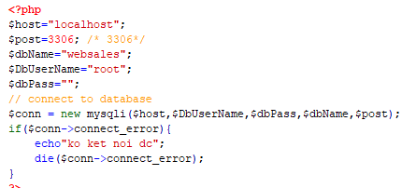

2.Add Cart

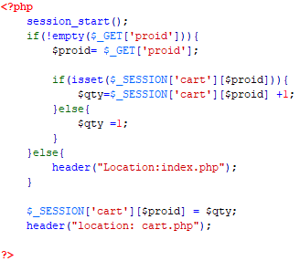

5.Login

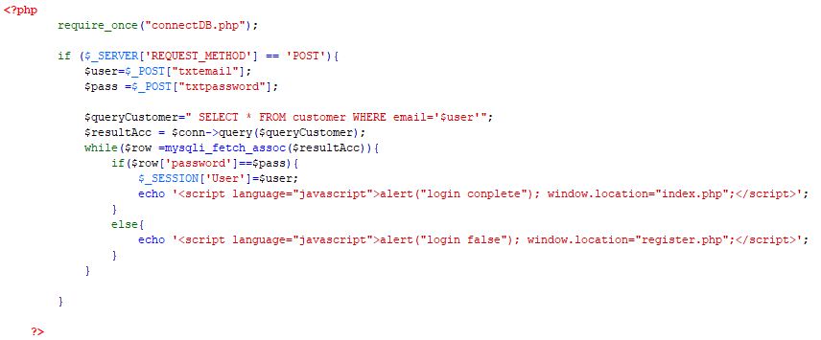

6.Logout

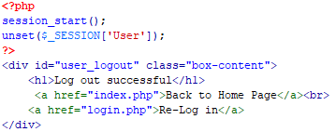

7.Sign Up

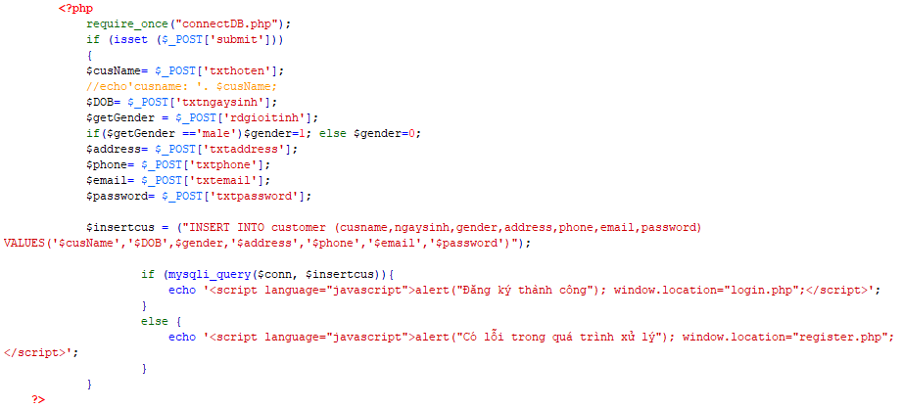

# V.Testing plan

## 1.Testing plan for user

|  |  |  |  |  |  |
| --- | --- | --- | --- | --- | --- |
| No | Function | Testing date | Result | Fixed date | Result |
| 01 | User login | 25/08/2020 | - Username or password is not correct but no message | 25/08/2020 | There is a message when user name or password is not correct |
| 02 | View product | 25/08/2020 | OK |  |  |
| 03 | User sign up | 25/08/2020 | did not fill in the information but did not show the notice | 25/08/2020 | Notification is shown when do not fill in the information |
| 04 | Adding cart | 25/08/2020 | Do not show products in cart | 25/08/2020 | Show products in cart |
| 05 | Order | 25/08/2020 | Order successfully |  |  |

## 2.Testing plan for admin

|  |  |  |  |  |  |
| --- | --- | --- | --- | --- | --- |
| No | Function | Testing date | Result | Fixed date | Result |
| 01 | Admin login | 25/08/2020 | OK |  |  |
| 02 | View product | 25/08/2020 | OK |  |  |
| 03 | Modify product | 25/08/2020 | Could not be done |  | Will add functions later |
| 04 | Add product | 25/08/2020 | Can’t add product | 25/08/2020 | Code Fixed |
| 05 | Delete product | 25/08/2020 | Can’t delete product | 25/08/2020 | Code Fixed |
| 06 | Admin login | 25/08/2020 | OK |  |  |
| 07 | Add product | 25/08/2020 | OK |  |  |
| 08 | Delete product | 25/08/2020 | OK |  |  |

# VI.Conclusion

* The advantages of my website:
* Very friendly user interface
* Use html 5+ css3
* Bootstrap
* Jquery
* The disadvantage of my website
* The site is quite simple and has few functions
* The fault is somewhere
* The future works
* Add payment function for users
* Allows users to change personal information
* Add order tracking function
* Compared to the estimated website. There are still some functions that have not been added yet.

## 

# *References*

Across the Board. 2020. *Should You Use An Ecommerce Platform To Sell Goods? - Across The Board*. [online] Available at: <https://blog.paylane.com/should-you-use-an-ecommerce-platform-to-sell-goods/> [Accessed 25 August 2020].